

**GROUP ASSIGNMENT**

**TECHNOLOGY PARK MALAYSIA**

**CT044-3-1-IOOP  
INTRODUCTION TO OBJECT ORIENTED PROGRAMMING**

**APD-APU1F2011CS(CYB)-CGD-CS(IS)-MMT-MMT(VRAR)-SE**

**HAND OUT DATE: 17 JUNE 2021**

**HAND IN DATE: 20 JULY 2021**

**WEIGHTAGE: 5%**



**INSTRUCTIONS TO CANDIDATES:**

**1  Submit your assignment at the administrative counter**

**2  Students are advised to underpin their answers with the use of references (cited using the Harvard Name System of Referencing)**

**3  Late submission will be awarded zero (0) unless Extenuating Circumstances (EC) are upheld**

**4  Cases of plagiarism will be penalized**

**5  The assignment should be bound in an appropriate style (comb bound or stapled).**

**6  Where the assignment should be submitted in both hardcopy and softcopy, the softcopy of the written assignment and source code (where appropriate) should be on a CD in an envelope / CD cover and attached to the hardcopy.**

**7  You must obtain 50% overall to pass this module.**

**CT044-3-1  
INTRODUCTION TO OBJECT ORIENTED PROGRAMMING**

**TITLE: UNIVERSITY ACCOMMODATION MANAGEMENT SYSTEM**

**INTAKE CODE:** APD1F2011CS(IS)/ APD1F2011(SE)

|  |  |  |
| --- | --- | --- |
| **Full Name** | **Student ID No.** |  |
| **ESLAM MAGDY REZK EBRAHIM HASSANIN** | **TP062816** | **1** |
| **Seitkerey Dinmukhamed** | **TP057390** | **2** |
| **ANAS YASSER MOHAMMED ABDELFATTAH HASSABOU** | **TP062438** | **3** |

**Date Assigned : 16 June, 2021**

**Date Due: 20 July, 2021**

Table of Contents

1. Introduction: 2

2. Milestone 1 – Storyboard: 3

Workload Matrix Template: 16

# **Introduction:**

The university accommodation application offers many advantages for students by booking their rooms online and choosing the appropriate rooms for them. Old students can also change their rooms from one room to another, listen to students’ opinions and improve the level of service in the accommodation by the officials by meeting their requests, Also, the warden responsible for the university accommodation can access all data and information in a smooth way to fully control the system and implement orders accurately and without errors.

# **Milestone 1 – Storyboard:**

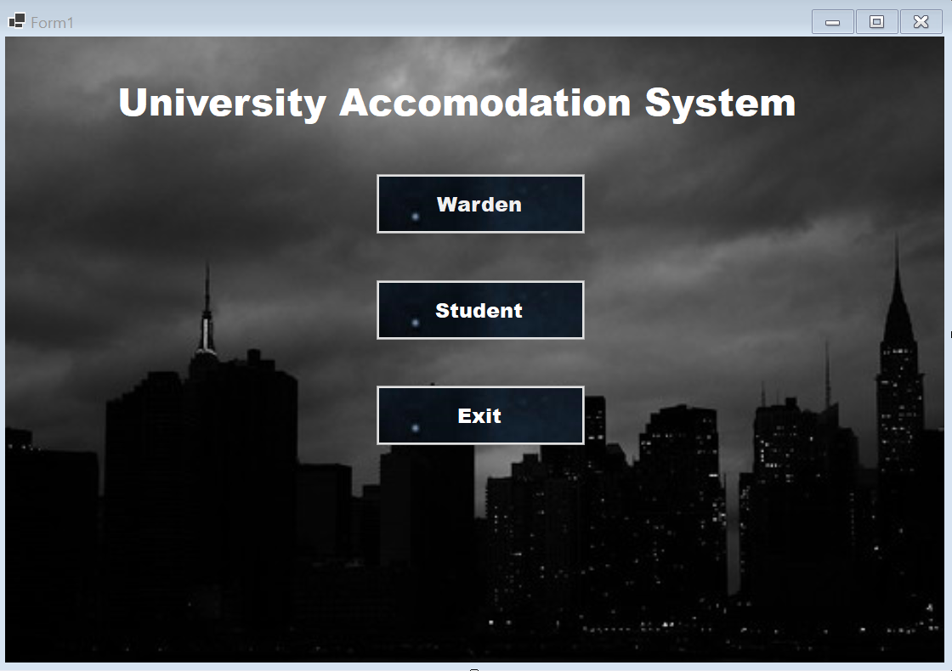

Button 3

Button 2

Button 1

Label1

|  |  |  |
| --- | --- | --- |
| **Login Menu** | | |
| **Description** | **Control Name** | **Control** |
| Title of the Main Menu | Label1 | Label 1 |
| Login for warden who manages student service only | btnWarden | Button 1 |
| Access to the student only | btnStudent | Button 2 |
| To “Exit” the Application | btnExit | Button 3 |

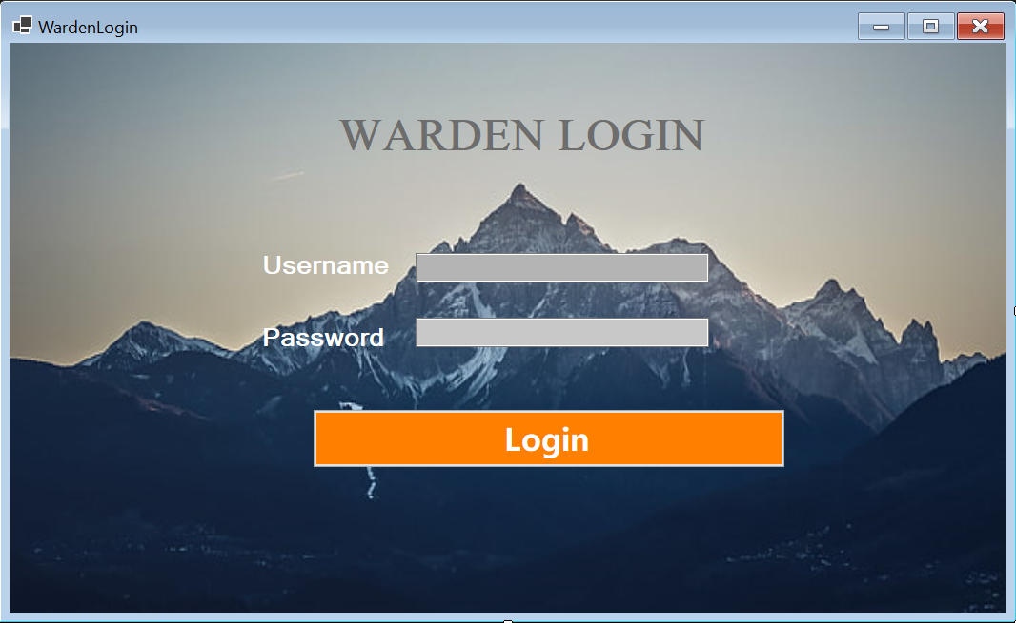

Textbox 2

Textbox 1

Button 1

Label3

Label2

Label1

|  |  |  |
| --- | --- | --- |
| **Warden Login Menu** | | |
| **Description** | **Control Name** | **Control** |
| Display “UserName” | Label2 | Label 2 |
| Display “WARDEN LOGIN” | Label1 | Label 1 |
| Display “Password” | Label3 | Label 3 |
| The Warden should write the correct username to can access to his account | txtUserName | Text box 1 |
| The Warden should write the correct password to can access to his account | txtPassword | Text box 2 |
| If the username and password are correct the warden should press on login to access to the dashboard | btnLogin | Button 1 |

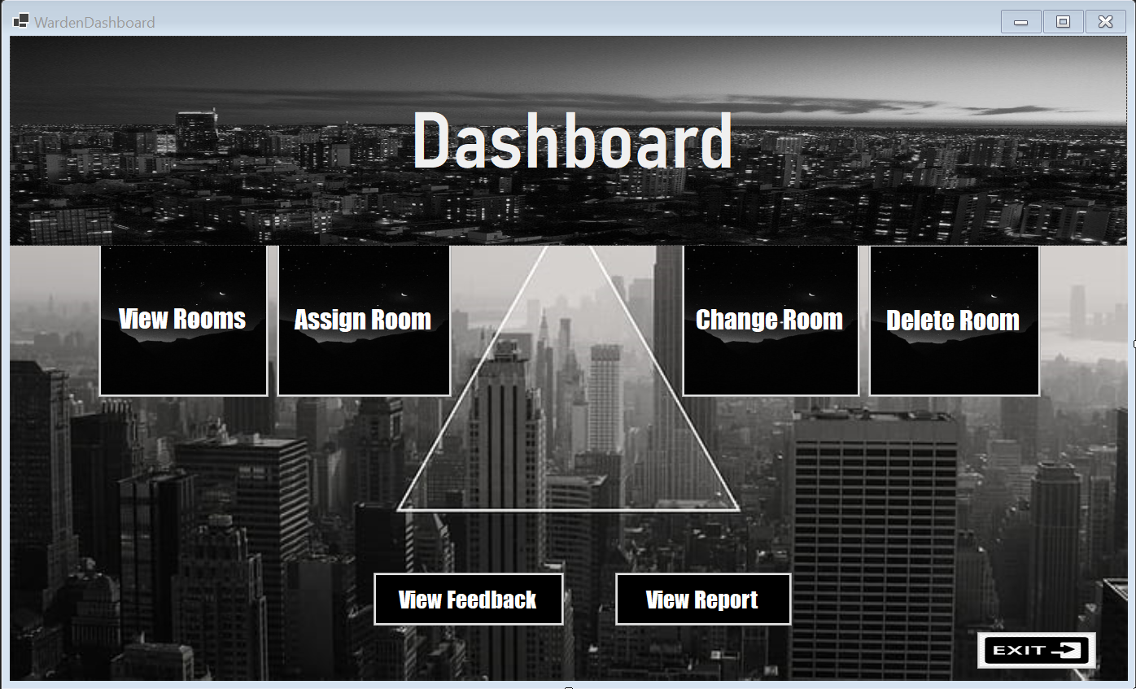

Button 7

Button 6

Button 5

Button 4

Button 3

Button 2

Button 1

Label1

Panel1

|  |  |  |
| --- | --- | --- |
| **Warden Dashboard** | | |
| **Description** | **Control Name** | **Control** |
| Includes the interface to define the shown menu | Panel1 | Panel 1 |
| Display “Dashboard” | Label1 | Label 1 |
| Make the warden access to all rooms in the accommodation and inform him which room is occupied and vacant | btnViewRooms | Button 1 |
| Let the warden to make a registration for a new student that applied for a room | btnAssignRoom | Button 2 |
| Let Warden to change room for students | btnChangeRoom | Button 3 |
| Let Warden to delete the room for student | btnDeleteRoom | Button 4 |
| Let Warden to see the status of the room for students if the room for student will be occupied or vacant with start and end date | btnViewReport | Button 5 |
| Let Warden to see the feedbacks of student | btnFeedback | Button 6 |
| Exit Application | btnExit | Button 7 |

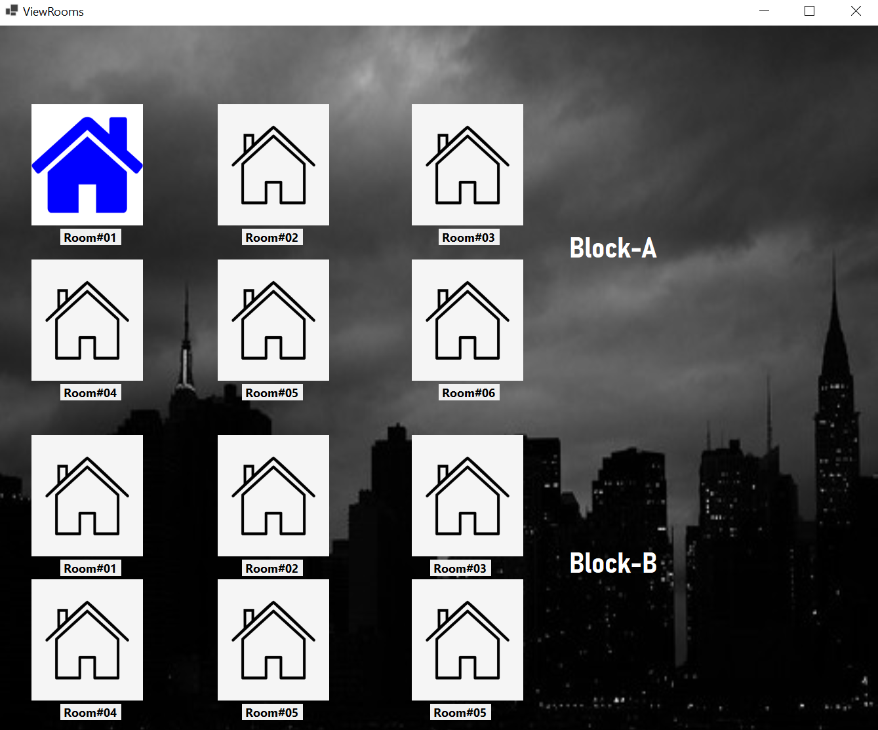

Label 3,4,5,6,7,8,9,10,11,12,13,14

Label 2

Label 1

Picturebox 12

Picturebox 11

Picturebox 10

Picturebox 9

Picturebox 8

Picturebox 7

Picturebox 6

Picturebox 5

Picturebox 4

Picturebox 3

Picturebox 2

Picturebox 1

|  |  |  |
| --- | --- | --- |
| **View Rooms** | | |
| **Description** | **Control Name** | **Control** |
| Display “Block-B” | Label2 | Label 2 |
| Display “Block-A” | Label1 | Label 1 |
| If the room is vacant the color will be white, the room occupied the color will be blue | pictureBox1-12 | Picturebox 1-12 |
| Display Room Number | Label 1-12 | Label 1-12 |

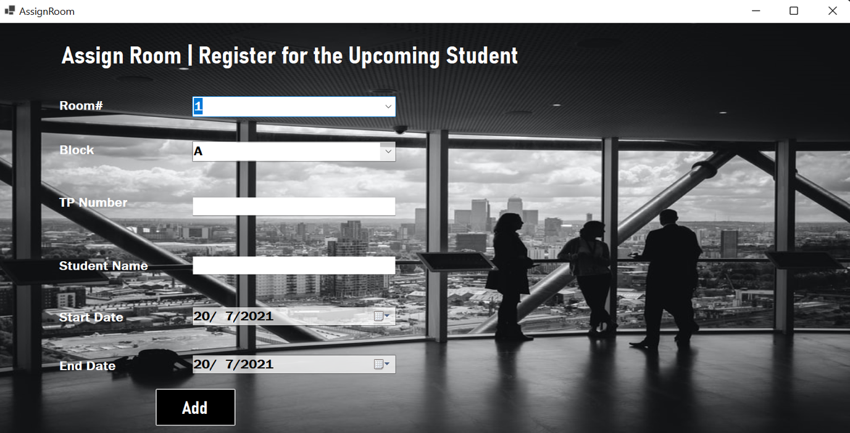

Label7

Label6

Button 1

DateTimePicker2

DateTimePicker1

TextBox 2

TextBox 1

ComboBox 2

ComboBox 1

Label5

Label4

Label3

Label2

Label1

|  |  |  |
| --- | --- | --- |
| **Assign Rooms** | | |
| **Description** | **Control Name** | **Control** |
| Display “Room#” | Label1 | Label 1 |
| Display “Assign Room | Register for the Upcoming Student” | Label2 | Label 2 |
| Display “Block” | Label3 | Label 3 |
| Display “TP Number” | Label4 | Label 4 |
| Display “Student Name” | Label5 | Label 5 |
| Display “End Date” | Label6 | Label 6 |
| Display “Start Date” | Label7 | Label 7 |
| After the warden fill the details of student, he should press on add button to save data | btnAdd | Button 1 |
| Warden should manage the start date for student | StartDate | DateTimePicker1 |
| Warden should manage the end date for student | EndDate | DateTimePicker2 |
| Warden should select the vacant room for the student | cmbRoomNo | ComboBox1 |
| Warden should choose block number to student | cmbBlock | ComboBox2 |
| Warden should write Student TP Number | txtStdID | TextBox1 |
| Warden should write the name of the student | txtStdName | TextBox2 |

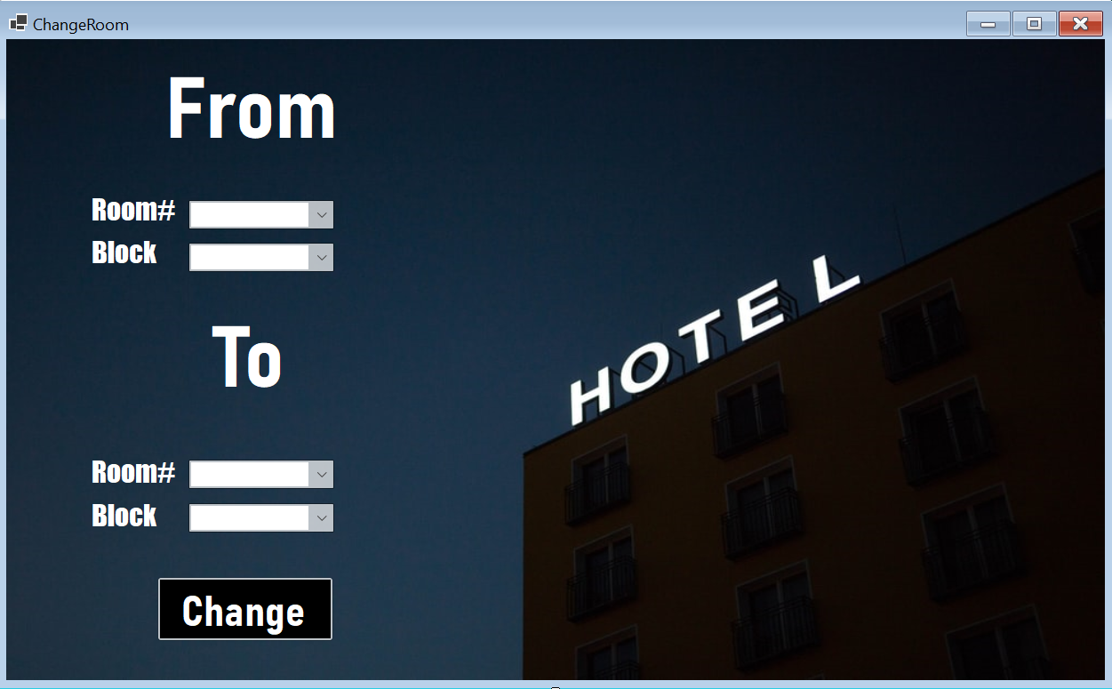

Button1

ComboBox4

ComboBox3

ComboBox2

ComboBox1

Label6

Label5

Label1

Label4

Label3

Label2

|  |  |  |
| --- | --- | --- |
| **Change Rooms** | | |
| **Description** | **Control Name** | **Control** |
| Display “From” | Label1 | Label 1 |
| Display “Room#” | Label2 | Label 2 |
| Display “Block” | Label3 | Label 3 |
| Display “To” | Label4 | Label 4 |
| Display “Room#” | Label5 | Label 5 |
| Display “Block” | Label6 | Label 6 |
| Warden select the room | cmbRoomFrom | ComboBox1 |
| Warden select number of block related to chosen room | cmbBlockFrom | ComboBox2 |
| Warden select the new room | cmbRoomTo | ComboBox3 |
| Warden select the type of block | cmbBlockTo | ComboBox4 |
| Warden save details and press on change button | btnChangeRoom | Button 1 |

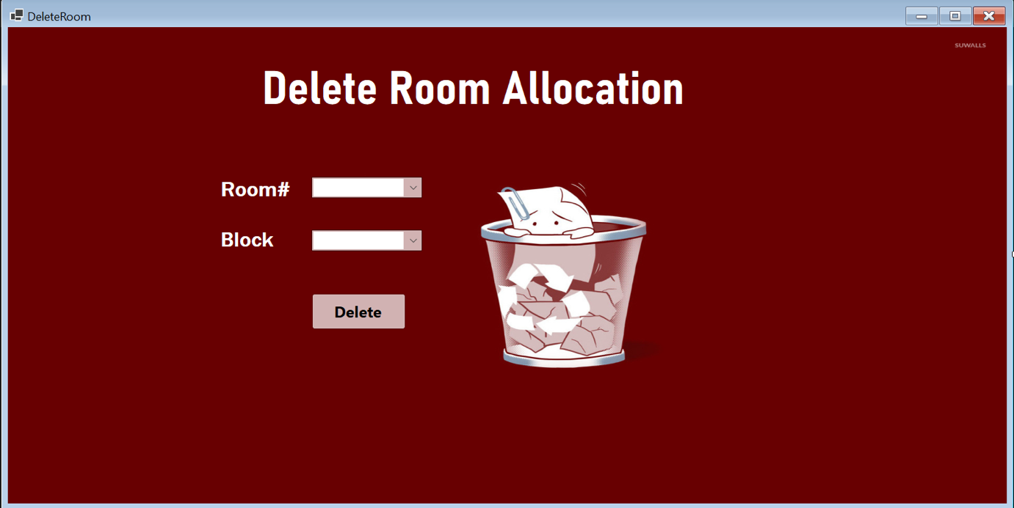

ComboBox1

Label1

Button 1

ComboBox 2

Label3

Label2

|  |  |  |
| --- | --- | --- |
| **Delete Room** | | |
| **Description** | **Control Name** | **Control** |
| Display “Delete Room Allocation” | Label1 | Label 1 |
| Display “Room#” | Label2 | Label 2 |
| Display “Block” | Label3 | Label 3 |
| Warden choose the block that related to the room to delete it | cmbBlockDelete | ComboBox1 |
| Warden choose the room that related to the block to delete it | cmbRoomDelete | ComboBox2 |
| Warden press on delete button to delete the chosen room with block | btnDelete | Button 1 |

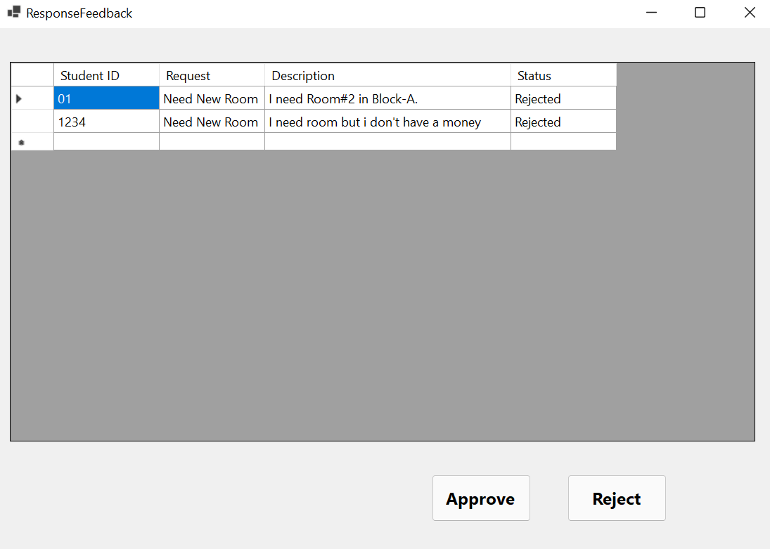

Button 2

Button 1

DataGridViewCell

|  |  |  |
| --- | --- | --- |
| **Feedback Response** | | |
| **Description** | **Control Name** | **Control** |
| Display “The requests of the student” | dgvFeedback | DataGridViewCell |
| Warden can approve the requests of the students | btnApprove | Button1 |
| Warden can reject the requests of the students | btnReject | Button2 |

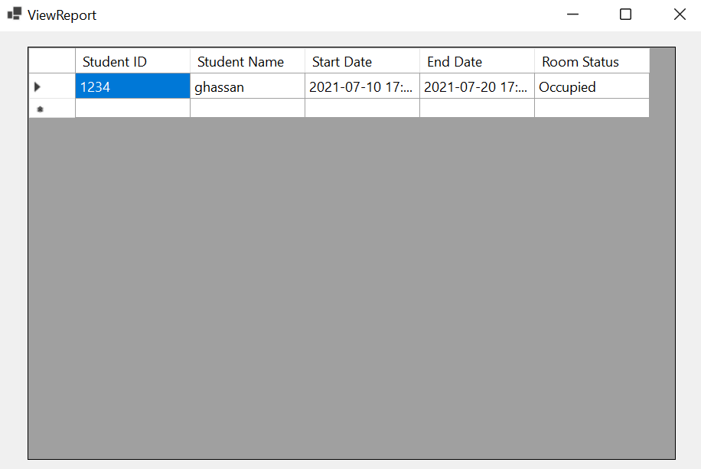

DataGridViewCell

|  |  |  |
| --- | --- | --- |
| **View Report** | | |
| **Description** | **Control Name** | **Control** |
| Inform the warden about room status if is it “occupied or vacant” | dgvFeedback | DataGridViewCell |

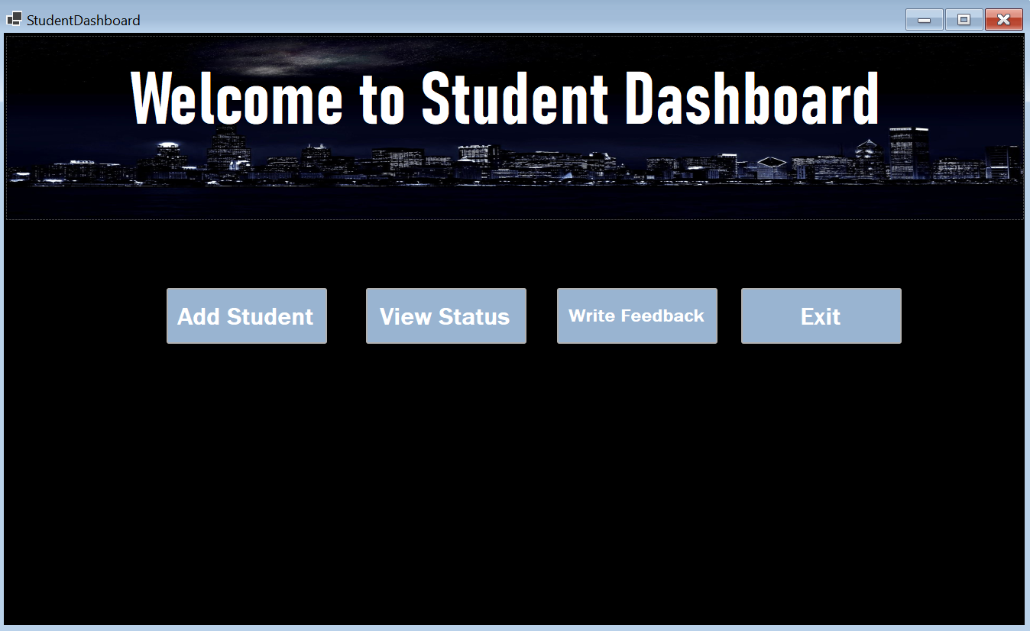

Panel1

Label1

Button4

Button3

Button2

Button1

|  |  |  |
| --- | --- | --- |
| **Student Dashboard** | | |
| **Description** | **Control Name** | **Control** |
| Includes title of the menu | Panel1 | Panel1 |
| Student can add his details and it will be received by warden | btnAddStudent | Button 1 |
| Student can check if his request is accepted or not | btnViewStatus | Button 2 |
| Student can write his feedback and send it to the warden of the accommodation | btnWriteFeedback | Button 3 |
| To Exit the Application | btnExit | Button 4 |
| Display “Welcome to Student Dashboard” | Label 1 | Label 1 |

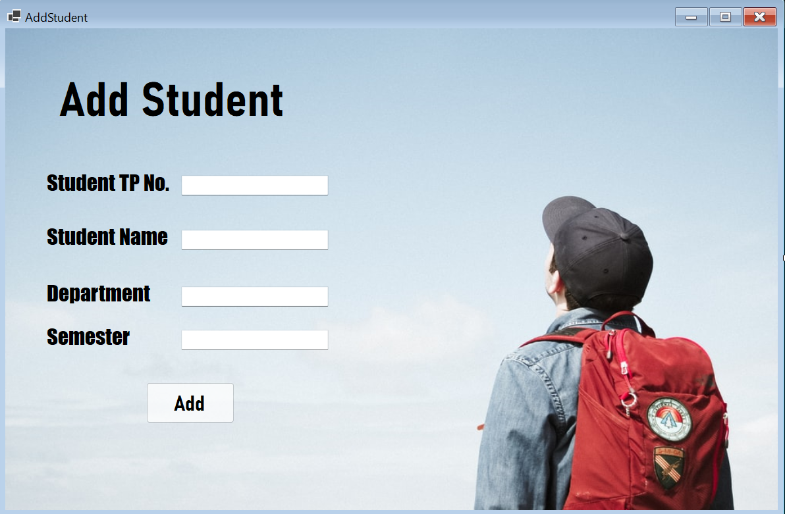

TextBox 4

TextBox 3

TextBox 2

TextBox 1

Button 1

Label 5

Label 4

Label 3

Label 2

Label 1

|  |  |  |
| --- | --- | --- |
| **Add Student** | | |
| **Description** | **Control Name** | **Control** |
| Display “Add Student” | Label1 | Label 1 |
| Display “Student TP No.” | Label2 | Label 2 |
| Display “Student Name” | Label3 | Label 3 |
| Display “Department” | Label4 | Label 4 |
| Display “Semester” | Label5 | Button 5 |
| The student After filling up this form he will save his details in the system by pressing on add button | btnAdd | Button 1 |
| Student will write here his TP Number | txtStdId | TextBox 1 |
| Student will write here his Full Name | txtStdName | TextBox 2 |
| Student will write here his department | txtDep | TextBox 3 |
| Student will write the currently semester | txtSemester | TextBox 4 |

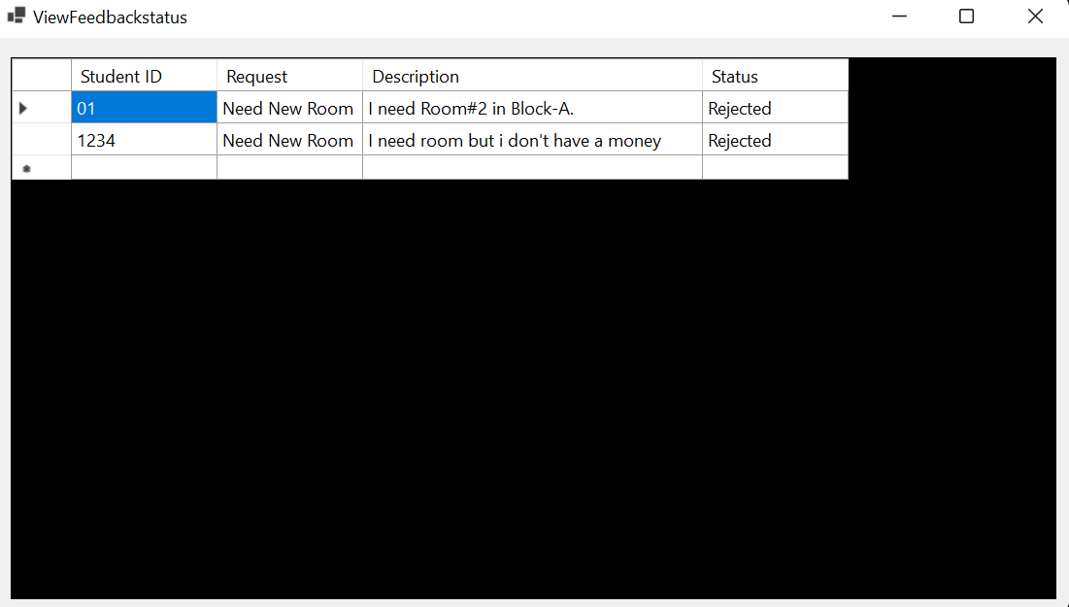

DataGridViewCell

|  |  |  |
| --- | --- | --- |
| **View Feedback Status** | | |
| **Description** | **Control Name** | **Control** |
| Inform the student about the status of his Request if is it “Accepted or not” | dgvFeedback | DataGridViewCell |

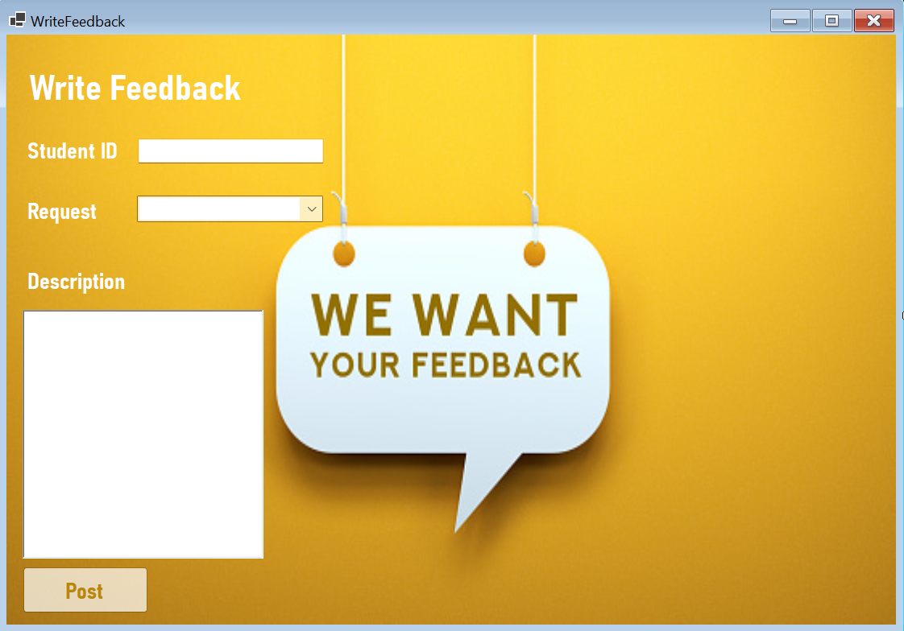

TextBox 2

ComboBox1

Button 1

Label 1

TextBox 1

Label 4

Label 3

Label 2

|  |  |  |
| --- | --- | --- |
| **Write Feedback** | | |
| **Description** | **Control Name** | **Control** |
| Display “Write Feedback” | Label1 | Label 1 |
| Display “Student ID” | Label2 | Label 2 |
| Display “Request” | Label3 | Label 3 |
| Display “Description” | Label4 | Label 4 |
| The student will press on post to send feedback to the warden | btnPost | Button 1 |
| Student will Write his own feedback about the service and accommodation | txtDescription | TextBox 1 |
| Student will write here his ID | txtStdID | TextBox 2 |
| The User will choose the reason for his own feedback like Need New Room, Change Room, and Terminate Room | cmbRequest | ComboBox 1 |

# **Workload Matrix Template:**

|  |  |  |
| --- | --- | --- |
| Name | Responsibilities | Contributions percentage |
| **Eslam Magdy Rezk Ebrahim Hassanin** | * Edit Documentation * Warden Storyboard | 50 % |
| **Seitkerey Dinmukhamed** | * Student Storyboard | 50 % |
| **ANAS**  **YASSER MOHAMMED ABDELFATTAH HASSABOU** | He did not commit to working with us and did not provide anything | 0 % |